

Confederated Tribes of the
Umatilla Indian Reservation
46411 Timíne Way
Pendleton, OR 97801
General Council

www.ctuir.org
email: generalcouncil@ctuir.org
Phone & Fax: 541-429-7378

General Council Agenda

November 20, 2025 - 2:00 PM
Hybrid: In-person & Virtual via Zoom

Call to Order
Note:
Only enrolled CTUIR Tribal Members permitted to attend.

Contact GC Staff Shawna Gavin at shawnagavin@ctuir.org for zoom meeting
ID & passcode

- Invocation

- Ascertainment of Quorum
  - General Council Officers
  - Board of Trustees
  - General Council Members

- Approval of Agenda

- Approval of Executive Summary – October 30, 2025

Old Business

Executive Orders / Administrative Update – Chanda Yates, Deputy Executive Director

New Business
  - 3rd Quarter Financial Report – Paul Rabb, Deputy Executive Director
  - Department of Children & Family Services – Lawanda Bronson, FDPIR Manager

Announcements/Notes

- Adjournment

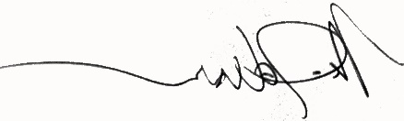
11/20/2025

Alan Crawford, Chairman - Michael R Johnson, Vice Chair - Martina Gordon, Secretary - Thomas Morning Owl, Interpreter

